First you need to successfully log in to the software: -

Follow the steps below to view all financial years.

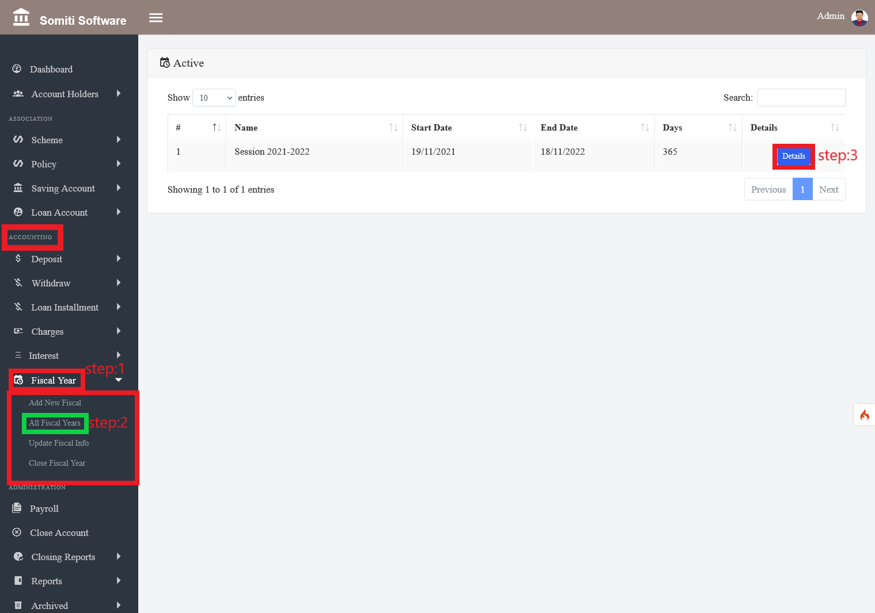

**Step-1**

Select the **financial Year** option from Accounting.

**Step-2**

After clicking on the financial year section a new list will appear. From there click on **all the financial year** section.

**Step-3**

After clicking on the section all the financial years will be seen. Click on the **Details** button to see all the information for the specific year.